Comparing Keyloggers
Name of Student
Institutional Affiliations

Comparing Keyloggers
A keylogger is a type of nefarious spyware that silently captures and records each keystroke that a user types on the keyboard of a computer. The keylogger captures each key that is pressed on the keyboard then stores it on a memory bank or file that is viewed by the attacker is observing in real-time or later (Zaytsev, 2007). The attacker searches the captured text for valuable information like credit card figures, passwords, web addresses, personal information, web searches, emails, chat room activity, and instant messages. Companies can also use the keyloggers on their PCs to supervise their personnel for internet searches and usage compliance by tracking activity and allowing the company to follow up on the unauthorized activity (Kizza, 2017). This research presents a detailed description, functions, and comparison of the keyloggers. Also, internet-based research will be conducted to identify different keyloggers that are available today. A table that summarizes five different hardware and software keyloggers, their available memory, specific features, and their cost be used to provide a snapshot of the keyloggers. Lastly, a report that details the findings on the functionality of the hardware and software keyloggers will be included in the paper.
Types of keyloggers
There are two different kinds of keyloggers, each with its exceptional benefits.

- Software keyloggers
These are programs which run in the PC background and in most cases silently records each keystroke that is pressed by the user into a file stored on the PC hard drive where it is modified and copied onto disks (Backes & Ning, 2009). Some of the software keyloggers have an additional feature of emailing the recorded keystrokes to pre-set email boxes where they can be accessed. This could cause an augmented detection risk if the user has fitted a software firewall like 'ZoneAlarm' since it will alert the user of the keylogger transferring file hence causing suspicious activity. Besides, other software keyloggers can monitor the inbound and outbound internet traffic and do screen captures. However, this slows down the fastest PC to a noticeable level. Also, the screen capture software can rapidly fill the space of the hard drive and bring about system stability issues. The software keyloggers are subdivided into two sub-classes: Visible in task manager and the invisible and stealth keyloggers.

- Hardware keyloggers
One of the ways of lowering the risks of sensitive data being retrieved by attackers is to use the hardware keylogger. The hardware keylogger can be used to record the keystrokes by merely plugging it between the PC and keyboard (Cole, 2011). Once connected, it starts recording each keystroke that conveys through it into its internal memory. Thus, no software will be needed to record the keystrokes using the KeyGhost keylogger. The KeyGhost is a complete autonomous hardware unit that plugs into a keyboard line of all PCs to record and recover keystrokes without ever installation of any software. The primary benefit of hardware keylogger is that it is totally undetectable using spyware scanners and software hence can be used for long-term and covert surveillance applications (Campbell, Calvert, Boswell, & Cisco, 2004). Hardware keyloggers are classified into two categories: Unsecured onboard and encrypted onboard memory.

Final Report
The first step was to conduct an internet-based research to identify five hardware keyloggers. Then, information on the hardware keyloggers’ available memory, explicit features, and respective costs were obtained from the Amazon website. The table highlights a summary of the key findings of the hardware keyloggers and their specifications.

Hardware Keyloggers | Memory | Key Features | Cost
AirDrive Keylogger  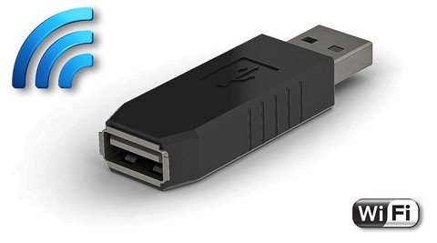 | 8 GB  Built-in memory | - Innovative ultra-small USB keylogger  - 0.8" in length.  - Wi-Fi hotspot accessible devices like computers, laptops, tablets, and smartphones  - Access keystroke info from web browser/email  - No need for software or applications  - Remote retrieval of data  - Supports over 40 keyboard layouts | $99.99
KeyGrabber USB  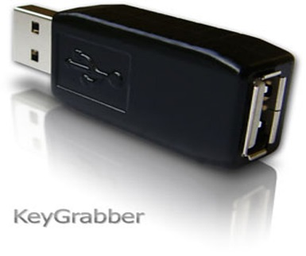 | 16MB  Built-in memory | - USB which allows super-fast data retrieval by switching into FlashDrive mode for downloading  - Ultra-stealthy and Top keylogging brand  - No software and drivers required.  - Organized into advanced flash FAT file  - Completely invisible for computer operation. | $35.99
KeyGrabber TimeKeeper  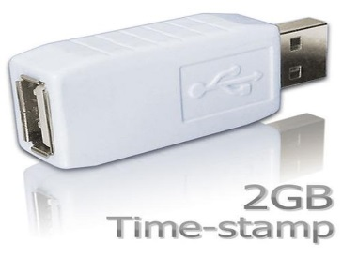 | 2 GB | - 100% MAC compatibility  - Battery life with 7 years guaranteed  - In-built timestamp module and a clock  - Wholly stealthy, invisible for the security software  - Flash drive USB functionality-instant memory | $73.99
KeyGrabber Wi-Fi Premium  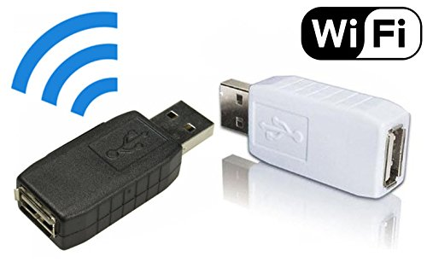 | 2 GB | - 100% MAC compatibility  - state-of-the-art: 2 powerful processors, full TCP/IPstack, WLAN transceiver  - Auto E-mail reports with detailed keystroke data  - Background connections to the Internet via local Access Points  - Fitted time-stamp module  - Flash drive functionality - instant access  - Enormous memory capacity  - Connect to local Wi-Fi Access Point | $99.95
AirDrive Serial Logger  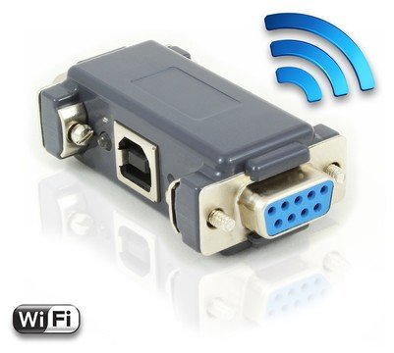 | 16 MB | - Logs asynchronous serialized transmissions (RS-232 compatible) up to 115200 bps  - Wi-Fi hotspot, connections from computers, smartphones, or tablet  - Accessibility of data from web browsers, no need for software or app  - USB-B side power socket (5V DC)  - The Pro & Max versions have time-stamp module, E-mail reporting, and data streaming, | $72

The second step was to conduct an internet-based research to identify five software keyloggers. Then, information on the software keyloggers and explicit features was obtained from books. The table highlights a summary of the key findings of the software keyloggers and their specifications

Software Keylogger | Key Features
Hypervisor-based | - The malware is a hypervisor that runs under the OS and rests untouched.  - It meritoriously becomes the virtual machine  - Blue Pill is a case of theoretical malware thought to be invisible even when the algorithms of the keylogger is openly recognized.
Kernel-Based | - The malware processes need to run in user space or kernel space.  - 95% of keyloggers run in the user space  - It needs a lot of proficiency to form the kernel-based keylogger.  - Hard to write and detect.  - Executed as root kits that can have access into the OS resources and act as keyboard driver.  - Requires the malware process to become super-user processes which make it hard for standard processes with low access level for detection
API Based | - There are vulnerabilities in the Windows API which make it easier for the antagonists to hook malevolent programs.  - A windows hook is at the core of the software keylogger.  - The hook is the stage within the system’s message that handles mechanisms where the applications can integrate a process to gain access to the messages that reach and leave the windows processes
Form Grabbing Based | - Keyloggers that log website submissions through storage web browsing on the submitted events.  - This occurs when the users complete forms and submit them, by clicking buttons or hitting the enter button.  - This keylogger records the form data then it is passed via the Internet.
Packet Analyzers | - These keyloggers capture network traffic linked with the HTTP POST event so as to decode passwords that are sent in normal text.  - HTTPS was launched to combat the attacks.

The third step was a comparison of the hardware keyloggers based on the information indicated in the table. The key findings about the about these devices were summarized in least three paragraphs.
The first comparison was based on memory storage. The AirDrive Keylogger had the least memory (8 MB) while KeyGrabber Wi-Fi Premium and KeyGrabber Wi-Fi Timekeeper had the highest memory (2GB). The hardware keyloggers can be used to 8 GB USB flash memory in reasonably small sized hardware (37mm). Hence, in the small-sized devices, one can securely store vast amounts of data.

Secondly, we used data security via encryption to compare the hardware keyloggers. The devices use 64/128 bit encryption systems to store the user data on the device securely, hence maintaining the privacy of the data. Besides, when the data transfer occurs spontaneously, it decrypts data and then stores it in the PC Hard disk. Therefore, both encryption and decryption processes take place mechanically without manual interferences. Hardware encryption protects the AirDrive Serial Logger and Airdrive key logger's memory. The KeyGrabber USB and key grabber timekeeper protected strong 128-bit encryption protects memory. The KeyGrabber Wi-Fi Premium memory is support by the WEP, WPA, and WPA-2 encryption.

Finally, we make a comparison based on the transmission of data through wired or wireless medium. The five hardware keyloggers highlighted in the table can transmit data through a wireless medium like Wi-Fi and Wireless-LAN connections for transmitting and storing data from various sources like computers and mobile devices. Hence, they are easily interfaced in comparison to wired keyloggers which. This enhances the compatibility of the interconnecting devices to different keyloggers for communication of data to occur efficiently without any physical connections between the operating system and the hardware keylogger.

The fourth step was a comparison of the software keyloggers based on the information indicated on the table. The key findings about the about the malware were summarized in last three paragraphs.

First, recording of keys that are being pressed at a specified moment. In this case, all the software keyloggers can track the users’ interaction with the operating system through a series of keyed interactions at a given time. Hence, we can deduce what the users typed with a specific file at a particular time.

Secondly, the malware can perform functions through different keys. Here, using Software keyloggers, one can lock or unlock monitor screens, lock taskbars or hide some icons from default use, disable use of some keys, enable the shortcuts for opening applications and files present on the OS, count keys’ frequency pressed by the users and the number of times a key was pressed. This helps the users to prevent system users from unauthorized access and use of private applications.

The final finding is that one can store the input data on the secure and hidden files. The software keyloggers can capture the data that is entered by users secretly without the user’s knowledge, store it in hidden files and transmitting the stored data to the attackers. This includes the password, User Id, and Email Attachments. This is dangerous as private and valuable data can get leaked without the user’s knowledge.

Conclusion and Recommendations

The main threat of keyloggers lies is that they depend on the keyboard input for authenticating users. A possible solution could be to eradicate the use of keyboards within the company to enter passwords. This can be achieved through the use of graphical passwords which involve the users clicking some points on images, sometimes using grids, in a sequence to produce the verification scheme. It is apparent that the keyloggers cannot act on such authentication schemes. Next, the hook keyloggers can be eliminated to some extent through the use of some anti-hook mechanisms by scanning the running processes to view if there is a current command that set the hooks. This is achieved by scanning dynamic linkage libraries that are linked to running procedures.

On the other hand, the kernel level keyloggers are quite problematic to curb as they assume different tactics. They might target the terminal to get the root passwords, which makes it easier to log in like ordinary users. Also, they may have mechanisms for overtaking the standard kernel procedures by posing as genuine kernel procedures. The threats are severe and occasional, yet not wholly uncontrollable as there are some methods of bridging the gaps at a semantic level and forming collaborations between the guest operating system and virtual machine. As well, there are specific mechanisms, the conventional approaches employed for the malware that is analogous to the viruses like the Signature-based and Behavioral scanning methods. Signature-based systems focus on the definitions of the structures of the malware while the behavioral schemes focus on the malicious behavior of specific software rather definitions or signatures.

However, it is not likely most of the times for the schemes to discover the behavior of keyloggers since the keyloggers pose as legitimate processes and might not even have palpable suspicious behavior. Also, they may rename themselves to avoid the signature-based scanning. Thus, no detection technique is fully potent against the keyloggers so we can conclude that the best means of combating keyloggers is avoiding their impact by circumventing their attacks only. Here, the concept of a Trusted Computing Base can be used as a mitigation mechanism. This is a collection of all software, hardware and business-ware components that are important to the system’s security, in the sense that any susceptibility that transpires in the trusted computing base can affect the entire system’s security.

References
Backes, M., & Ning, P. (2009). Computer Security - ESORICS 2009: 14th European Symposium on Research in Computer Security, Saint-Malo, France, September 21-23, 2009. Proceedings. Berlin, Heidelberg: Springer Berlin Heidelberg.
Campbell, P., Calvert, B., Boswell, S., & Cisco Learning Institute. (2004). Security+ guide to network security fundamentals. Australia: Thomson/Course Technology.
Ciampa, M. D. (2015). Security+ guide to network security fundamentals. Boston, MA: Course Technology, Cengage Learning.
Ciampa, M. D. (2017). Security awareness: Applying practical security in your world. Boston, MA: Cengage Learning.
Cole, E. (2011). Network Security Bible. Hoboken: John Wiley & Sons, Inc.
Kizza, J. M. (2017). Guide to computer network security. Cham, Switzerland: Springer.
Zaytsev, O. (2007). Rootkits, spyware/adware, keyloggers and backdoors: Detection and neutralization. Wayne, Pa: A-List.

